ECE Senior Design Weekly Report

**Engineer’s Name:** Leon Tran             **Date:** 03/01/17

**Team Name:** The Globetrotters **Lab Section:** 4

**Week’s Task:** Add more Features to the World Map for the Monitor. Construct a Project Plan with Milestones and a general Outline

**Results:**

* **QGIS Map**
  + **Connected QGIS Map to ESRI’s World Imagery base map**
    - It is a high-resolution satellite and aerial image map
    - Must be connected to Wi-fi to view the high-resolution images

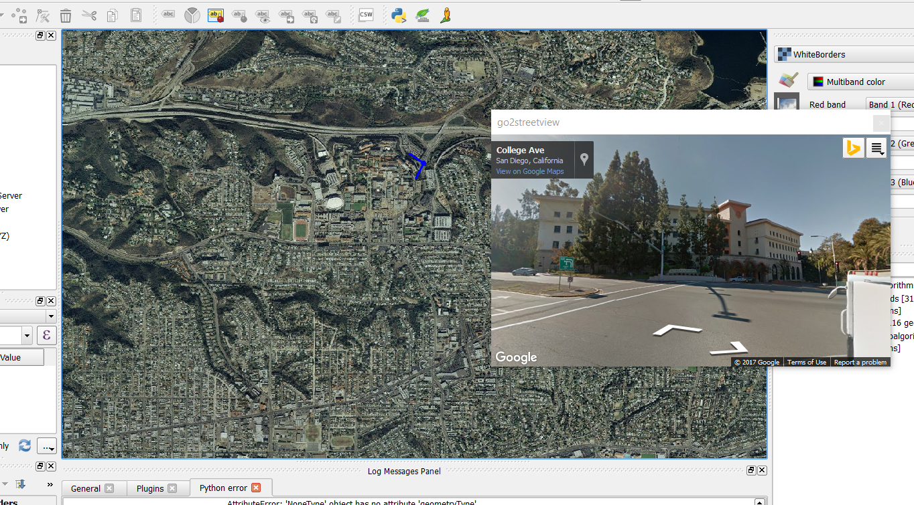

* + **Connected to Google street view**
    - Able to have an aerial or street level view anywhere on the map that Google has coverage on
  + **Constructed basic HTML Display of the info**
    - Drafted a rough draft of how we are going to display the info that the user requests.